Healthcare Fraud Prevention - Study Management Server - Core Assembly
Deployment Guide

Revision History
Author | Revision Number | Date
caoweiquan322 | 1.0 | 11/18/2013

1. Submission Organization 3
2. Environment 3
3. Environment setup and configuration 3
3.1 Dependencies 3
3.2 Configuration 3
4. Verification 4
4.1 Start server 4
4.2 Test user management 4
4.3 Test email management 7
4.4 Test partner tags management 9
4.5 Test partners management 14
4.6 Terminate Django server 17
5. Resource Contact List 17

Submission Organization
This assembly is organized as follows:
- ./Healthcare Fraud Prevention - Study Management Server - Core Assembly Deployment Guide.doc – this document.
- ./hfppnetwork - code of this assembly, including the python code/django templates/javascripts.

Environment
The assembly was done and tested under folloing environment:
- Ubuntu 12.04.3 LTS 64-bit
- Python 3.3.2
- Django 1.6 https://www.djangoproject.com/

Browser used by verification is Firefox.

Environment setup and configuration

Dependencies
We assume that you have python3.3 fully installed.
sudo apt-get install zlib1g-dev
sudo apt-get install openssl
sudo apt-get install libssl-dev
wget http://www.python.org/ftp/python/3.3.2/Python-3.3.2.tar.bz2
tar xvf Python-3.3.2.tar.bz2
cd Python-3.3.2
./configure
make
sudo make install

Install depend libraries:
Download django 1.6, extract it.
cd Django-1.6
sudo python3 setup.py install

You can check Django-1.6 was sucessfully installed by running following python shell:
python3
>>> import django
>>> print(django.VERSION)

Note that it's possible that your django doesn't run well. This is mainly because your python3 was not fully installed.

Configuration
There are following parameters to set in hfppnetwork/hfppnetwork/settings.py. Here are the sample settings, you need to adapt it to your environment.

Name | Description | Example
TEMPLATE_DIRS | Directories to search for the template files(.html files). Note that eve if you have only one directory to set, ensure there's one “,” after the path string. MUST be absolute path. | “/home/tcsassembler/tcs/hfppnetwork-CoreAssembly/hfppnetwork/templates”
STATIC_PATH | Directory to search the js/image/css files. MUST be absolute path. | “/home/tcsassembler/tcs/hfppnetwork-CoreAssembly/hfppnetwork/media”
DATABASES.NAME | Path to the sqlite db file. MUST be absolute path. | “/home/tcsassembler/tcs/hfppnetwork-CoreAssembly/hfppnetwork/sqlite.db”

Verification

Start server
After configured settings.py, you can start web server by following commands:
cd hfppnetwork
python3 manage.py syncdb
python3 manage.py runserver

You will be asked to create a super user during syncdb. Please follow instructions of django. The super user I created is:
username: tcsassember
passowrd: tctest

Test user management
Open your browser, type url “http://localhost:8000” you can see the login page:

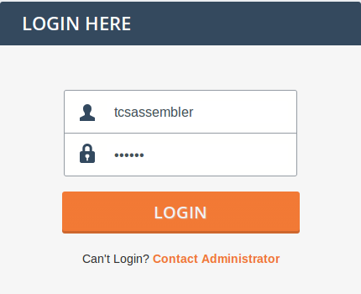

Input you super username and password created in section 4.1, and click login to login.
Staff users will be directed to /admin/auth/user page by default.

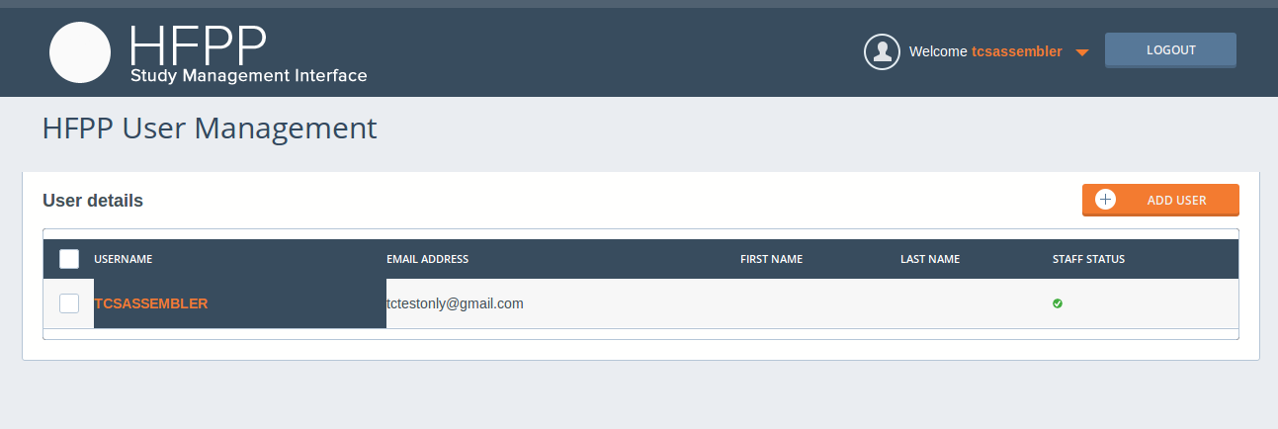

Hover mouse on the user name on top right of this page, a fly-out will come out leading you to different links. Click the user name(tcsassembler here) itself will direct to the user profile.

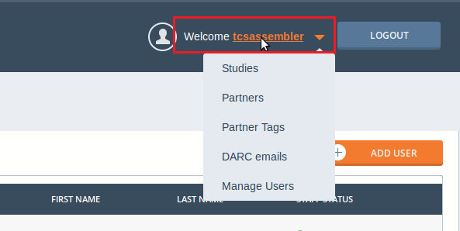

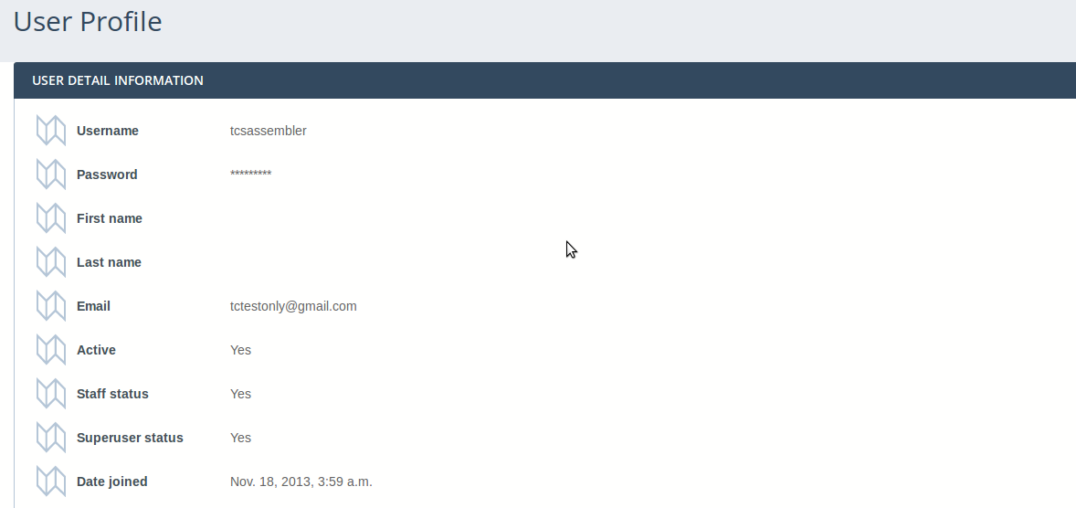

Go back to the user management page, and click the yellow “ADD USER” button, this will direct you to create user page:

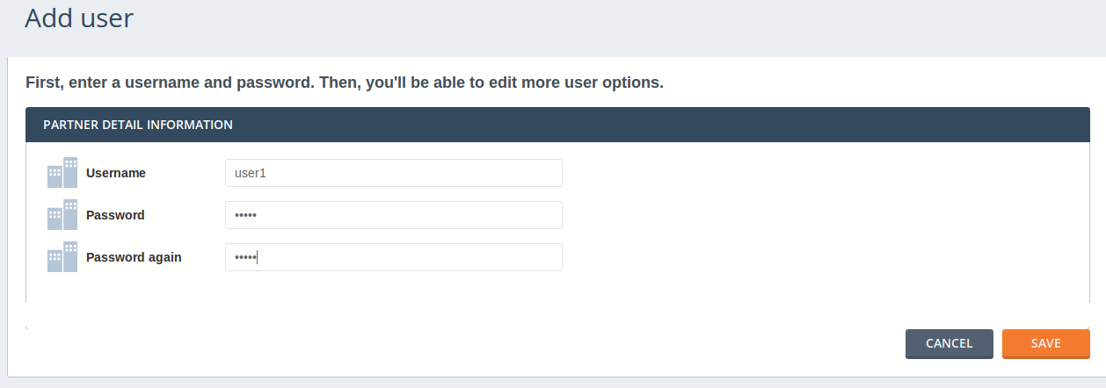

Input username and password, click SAVE button will go to the page which give you chance to edit the user information in details. The user I create here is “user1/pass1”.

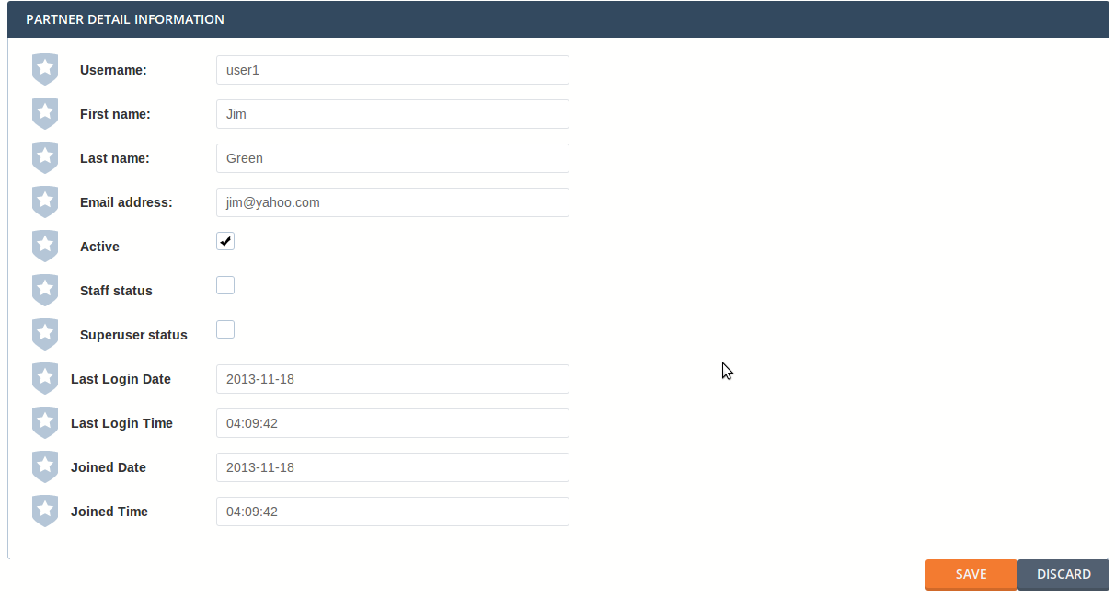

After fill in the name/email/staff_status information, click SAVE button will lead you to the user management page again. Here we can see new user has been added. What’s more, details like email/first name/last name/staff status are also shown.

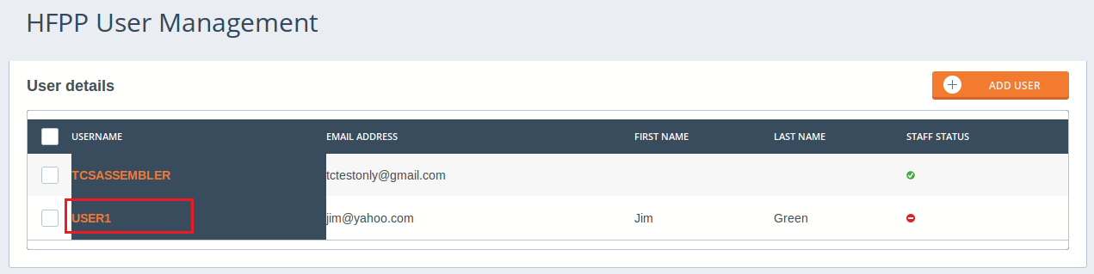

You can also click the hyperlink username(RED frame in above screenshot) in the table to edit user information for each user. For example if you click USER1, you can go on edit the user information:

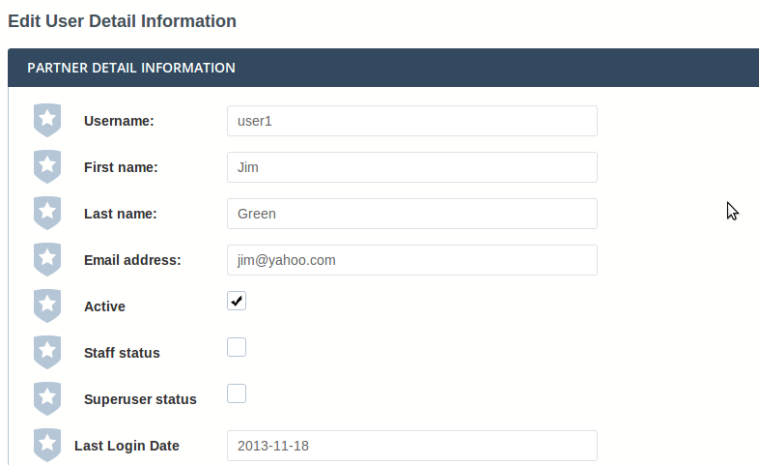

Test email management

Click DARC Emails on top right of the page, you can edit DARC emails:

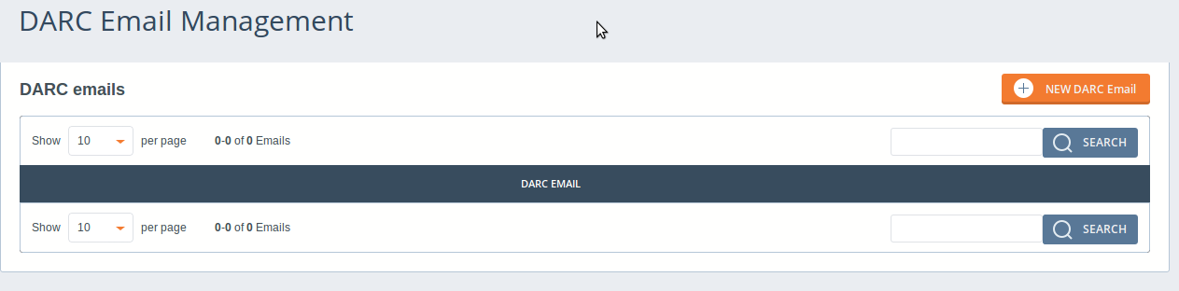

There’s no emails at present. Click orange NEW DARC Email to create one:

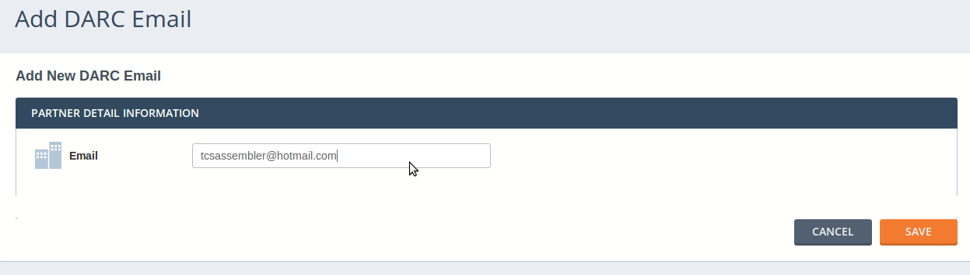

Click SAVE to return to email management page. Go on adding more pages to test pagination of this web page. Here I added 6 users in total:

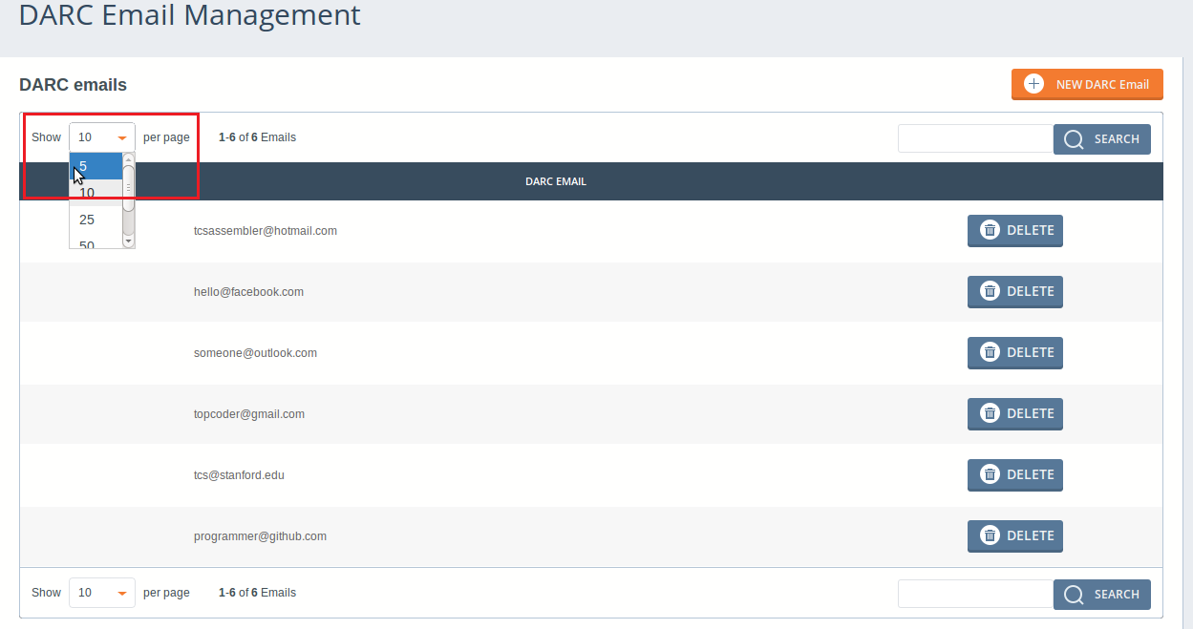

Select different number of items to show in each page to see the effect. If you choose 5 items per page as I did, you will see a NEXT button. And only 5 items will be there within this page, of course.
Note that if I follow the advice of this assembly, making NEXT button a hyperlink, the button will look ugly and different from the prototype. I used javascript to handle this instead.

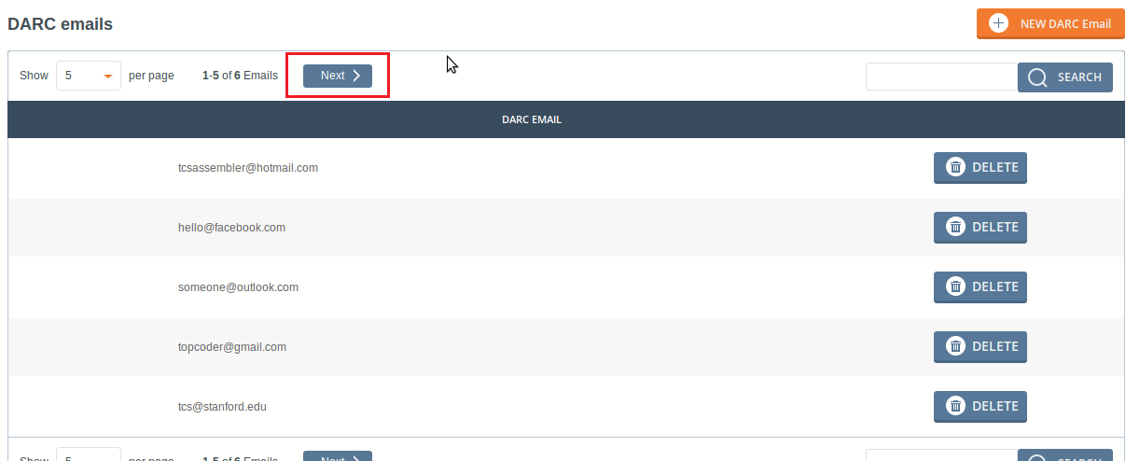

Click NEXT button, see the last email that I added before. And also a Previous button will be shown.

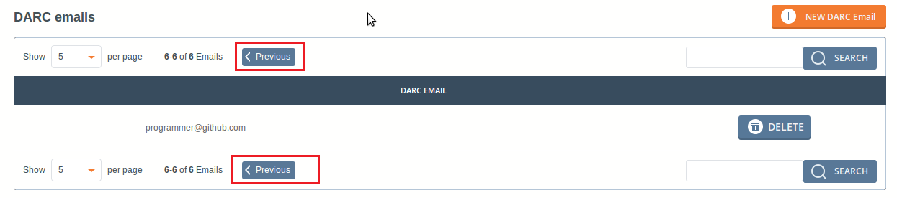

Try search functionality of this web page. Type topcoder@gmail.com, click SEARCH button, you can see only the filtered email will be there.

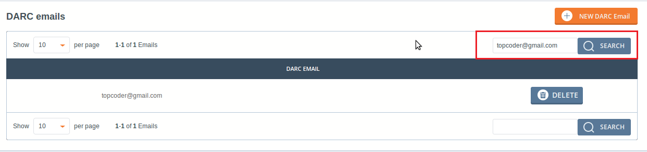

Search with blank content will show back all the emails.
Click DELETE button will remove the email from database.

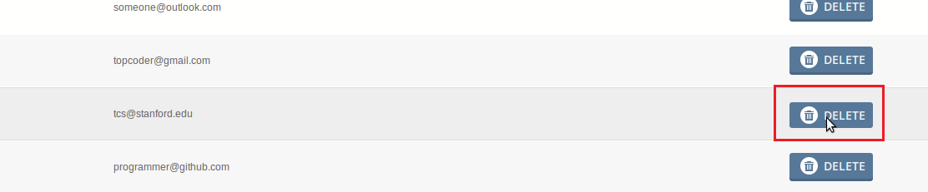

See now there are only 5 emails.

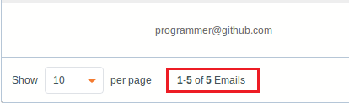

Test partner tags management

Logout and login with the general user we has just created(user1/pass1 in my case):

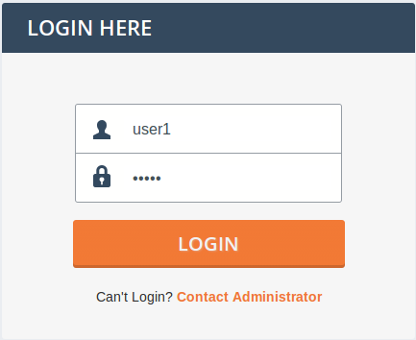

For general users, server will redirect to /studies by default, which is not implemented by this assembly.

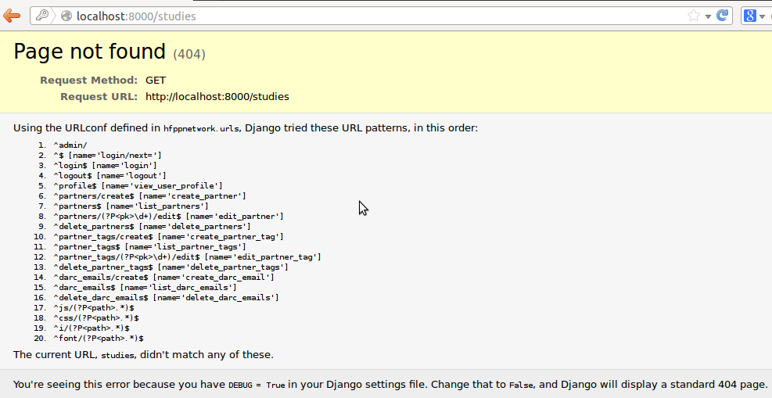

Type another url in the navigation are, say: http://localhost:8000/profile. Here you can see profile of this user. User can NOT edit their profiles themselves.

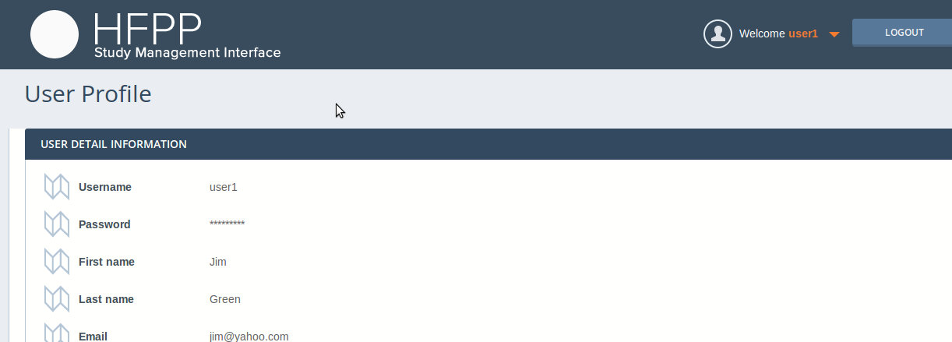

Click Partner Tags on top right go to the page managing partner tags. This page is quite similar to that of DARC Email management.

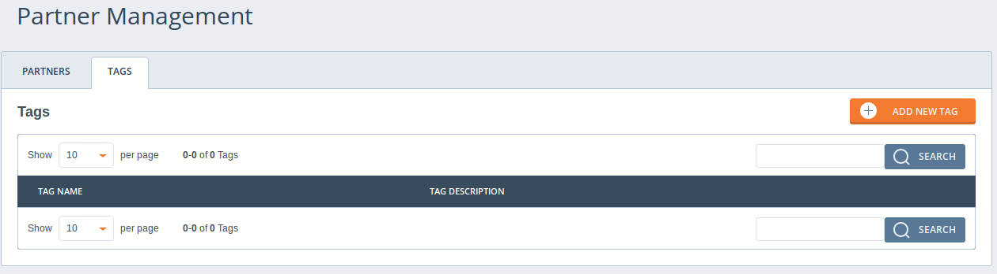

Click ADD NEW TAG button to add new tags. I also added 6 tags here.

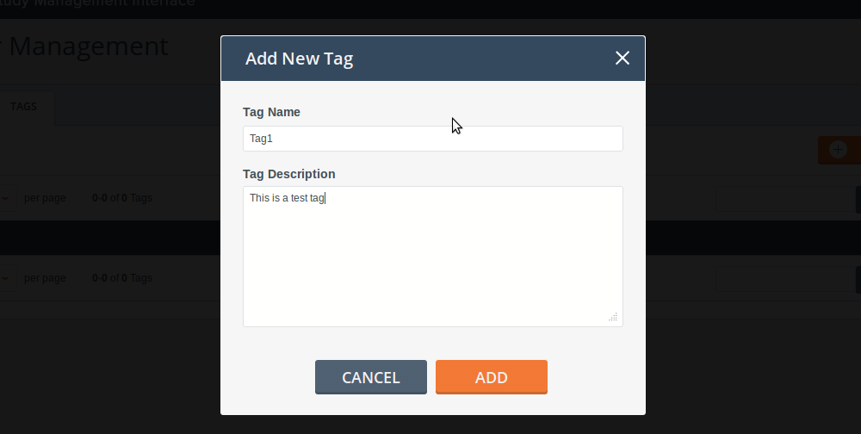

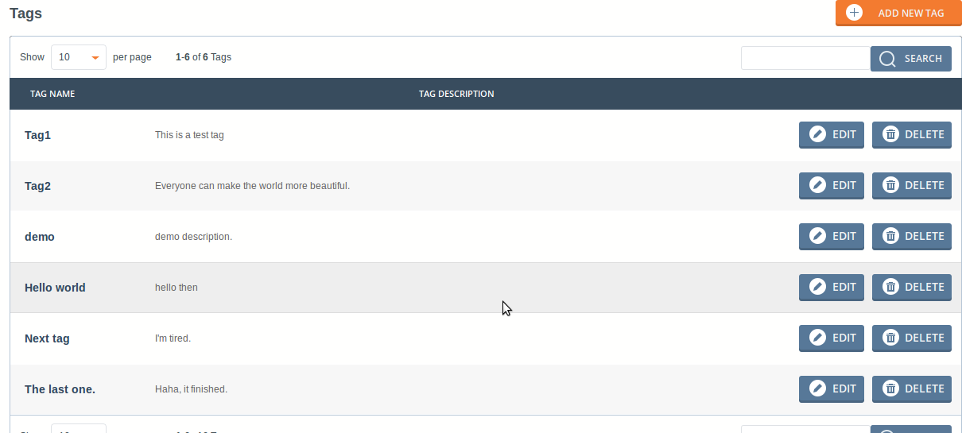

Choose again number of tags be shown in one page, say 5. This will verify pagination of this page.

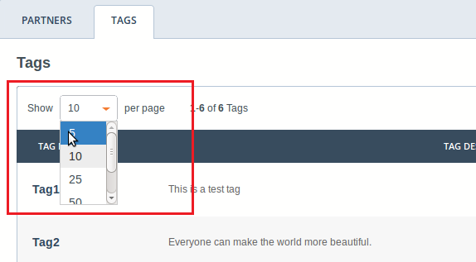

You see NEXT or Previous buttons will shown up similarly. And also only 5 items.

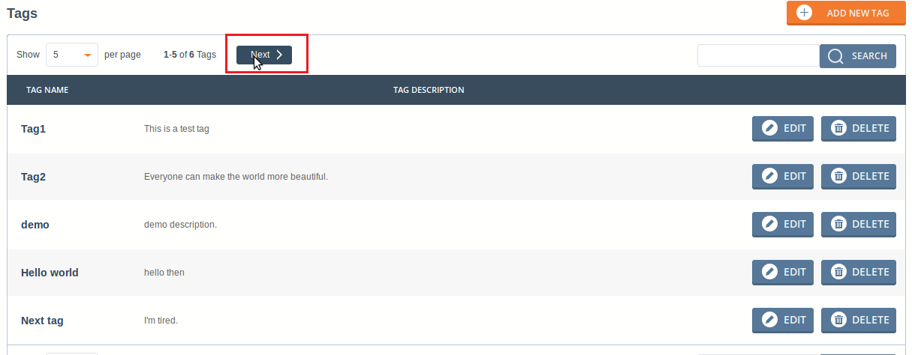

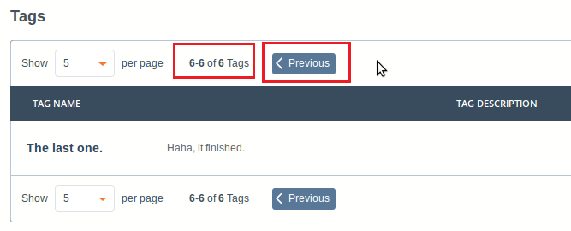

You can also search tags by typing tag titles and click SEARCH button.

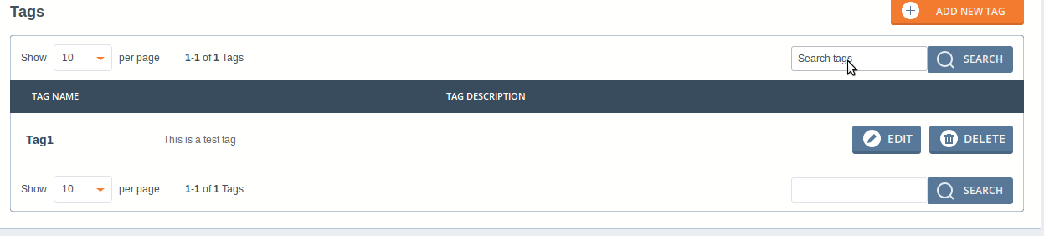

Click EDIT button at each row will give you chance to edit that tag:

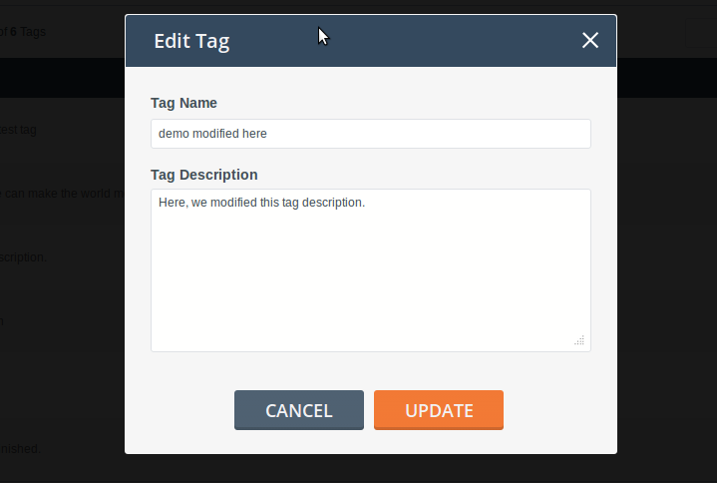

Check that the tags are really modified.

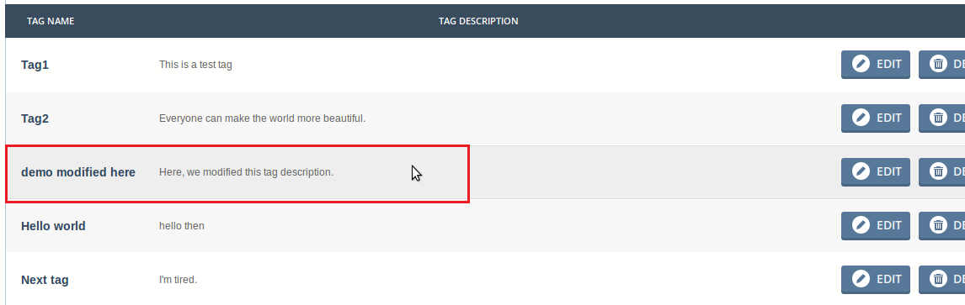

Also you may try to DELETE any item.

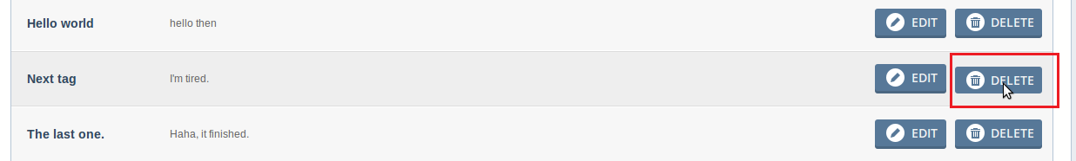

Test partners management

Click PARTNERS tab on top will go to partners management page. There’re no partners yet.

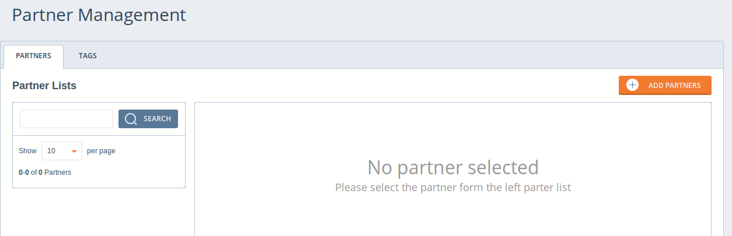

Similarly add one partner by clicking ADD PARTNERS button:

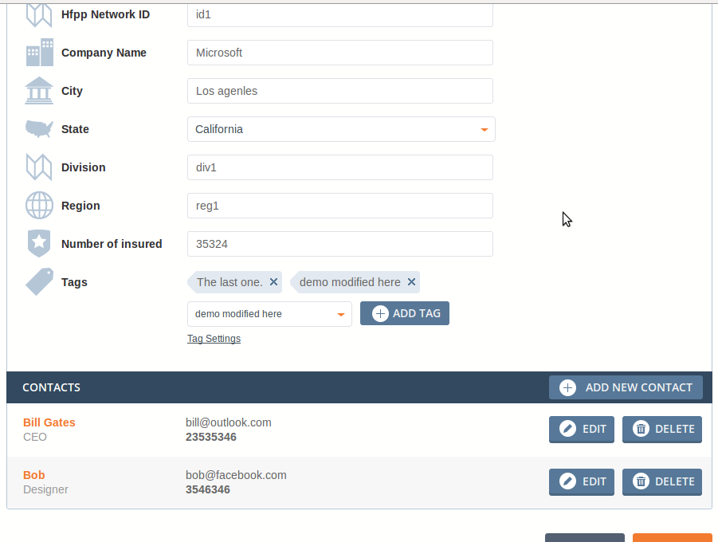

During adding partners, you can click ADD NEW CONTACT to add new contacts for this partner.

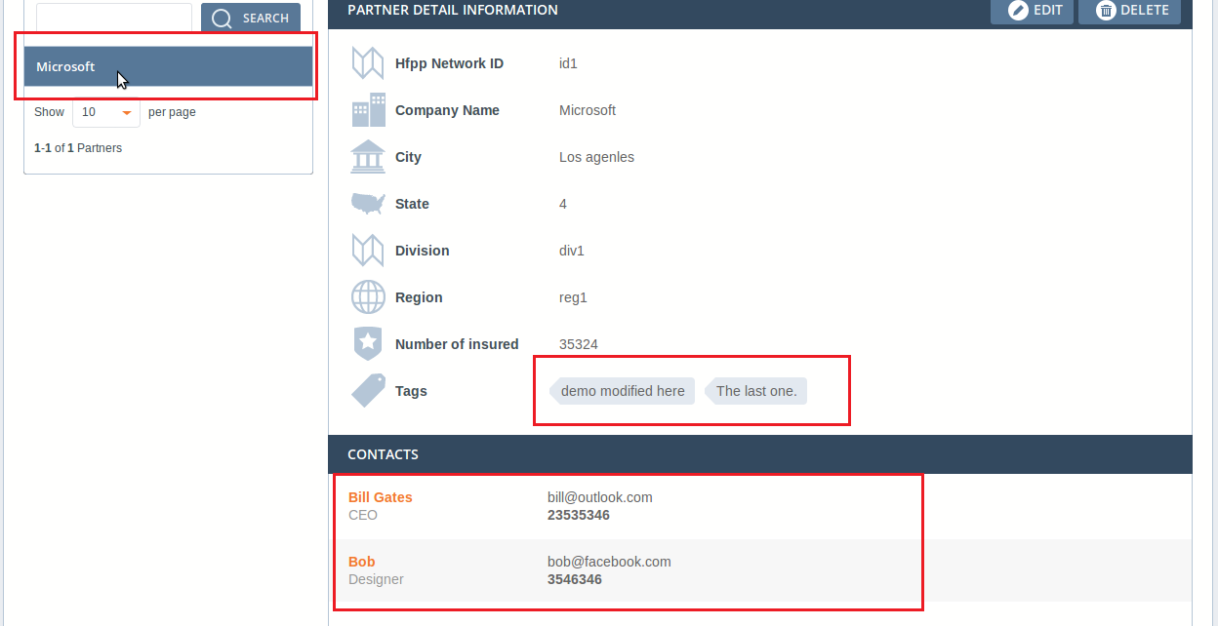

There’s one item now. You can see contacts details by click the orange contact names(e.g. Bill Gates or Bob):

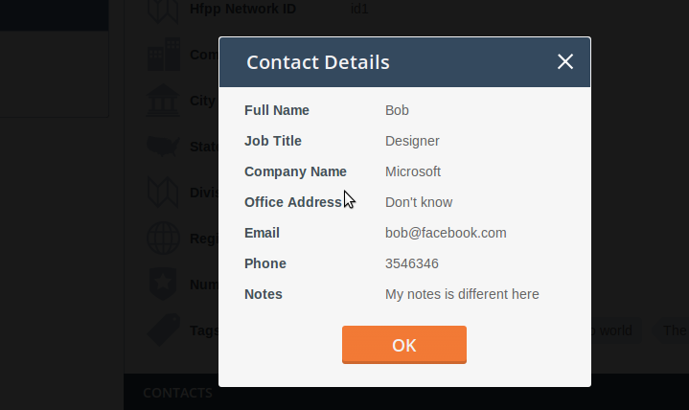

Click EDIT button on top right to edit the partner information. You may change company names/city/region, adding new tags, changing contacts, delete contacts, adding new contacts and so on.

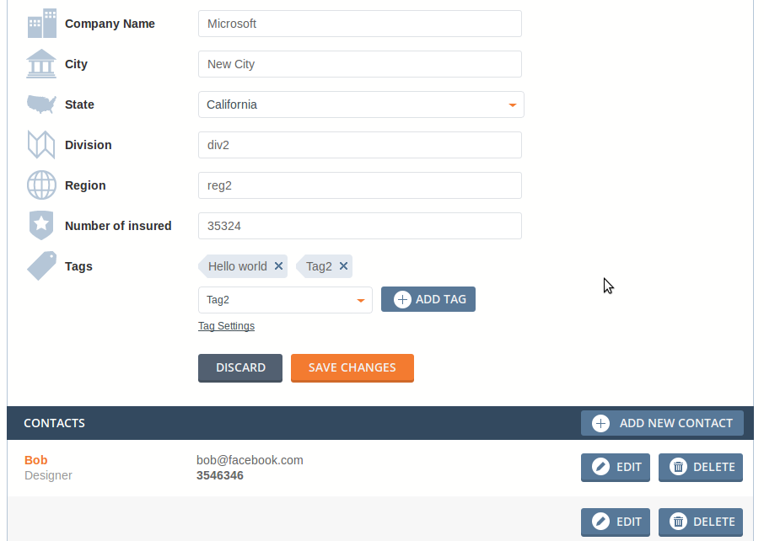

After updated, the new partner information is there.

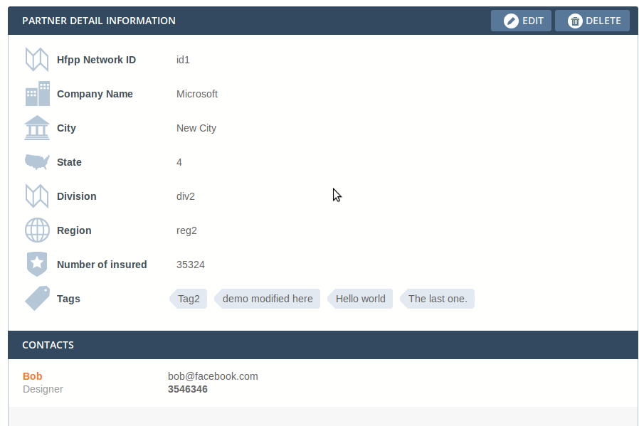

Clicking DELET button on top right will cause a modal come up verifying you to delete it.

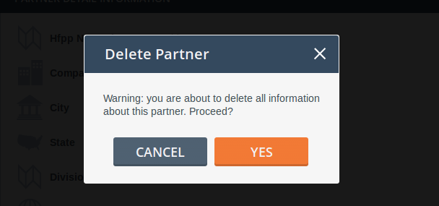

Click YES and see that now there’s no partners again.
You can also add more partners and to see that pagination and search functionalities work well for this page too.

Terminate Django server

Terminate django server by CTRL+C in Ubuntu OS.

Resource Contact List

Name | Resource Email
caoweiquan322 | caoweiquan322@126.com

